Churn model
Study customer leaving
- The goal is to predict which customers are most likely to leave so the company can apply the appropriate retention marketing campaigns
- Focus on repeat customers and analyze the main characteristic of the customers leaving the company
- Assign to each repeat customer its probability of leaving

Methodological approach
- definition of the target
  - evaluate type of scenario of leaving
  - identifier outlier values
  - exploratory analysis prior to development of model
- define analysis perimeter and divide into
  - observation period: period to calculate potential explanatory variables
  - latency period: time to calculate variables
  - churn period: time to verify customer’s behavior to define target variable

- balancing: verification of balance of dataset through:
  - undersampling
  - oversampling
  - synthetic-data generation
- train-test, cross-validation: algorithms to estimate probability of leaving

- Main performance measures for churn and repurchase models are
  - AUC: area under ROC curve
  - Accuracy
  - Recall

Explorative analysis
Repurchase curve:
- 90% of repeat customers repurchase within 12 months
- Important to maintain frequency of repurchase within this time period
Probability of return:
- probability of first time customers returning 30.3% (the complementary of customers do not return to make second purchase)
- as purchase increase, loyalty increases with higher propensity to repurchase

Definition of analysis time period
- Churn model built on repeat customers, with 2 purchases in time period

Feature selection
Two types of tests used to test statistical significance of variables to be included within Churn model:
- T-Test (numerical variables) with α = 0.05% (for p-values ≤ 0.05 null hypothesis rejected)
  - Null hypothesis (H0) → two averages equal between the two groups (difference due to change)
  - Alternative hypothesis (H1) → two averages significantly different from each other
- Chi-square (categorical values): test dependence between categorical input variables and target variable. With α = 0.05% (for p-values ≤ 0.05 null hypothesis rejected)
  - Null hypothesis (H0) → independence between the two variables
  - Alternative hypothesis → dependence between two variables

Churn Model development

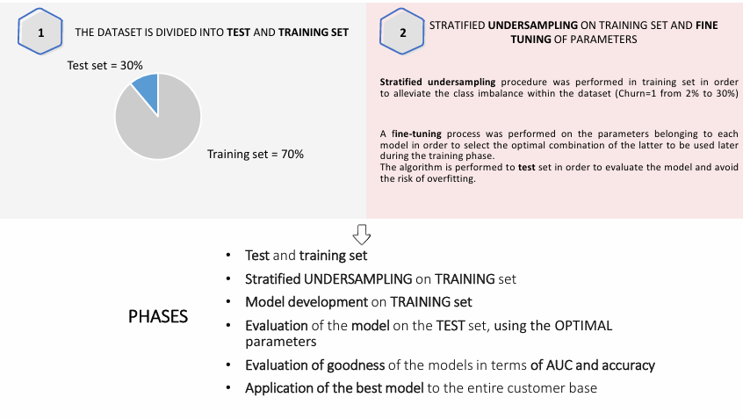

Model results

From implementation of random forest model, variables with greatest impact were identified.

Repurchase model
Study the probability of a repurchase by a new customer
- Focus on one-shooters, who made a first and only one purchase with the aim of estimating the probability of repurchase

Main steps to develop churn or repurchase model

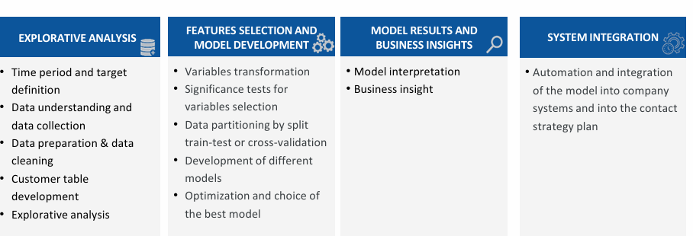

Explorative analysis
Distance from registration date to first purchase
- Around 90% of customers make first purchase within seven days before or after registration date
Definition of analysis time period
- Repurchase model developed on new customers whose registration is between a time period of two years and who made their first purchase in a time interval of seven days before or after registration.
- Target identified in 12 months following first purchase
  - Target 0: no purchase within 12 months of first purchase
  - Target 1: purchase between 12 months of first purchase

Model results
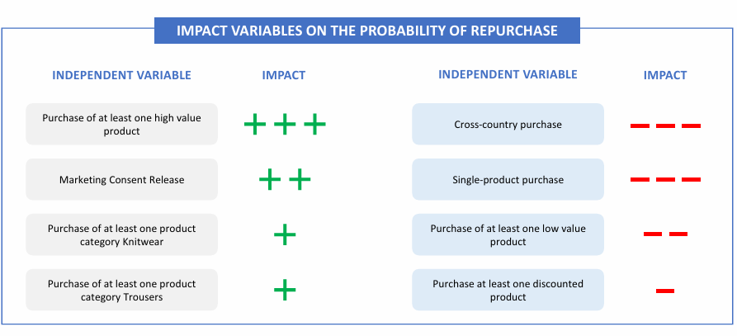
Benefits and limitations of churn and repurchase models

